Creating text on a path
Choose a picture similar to this one.
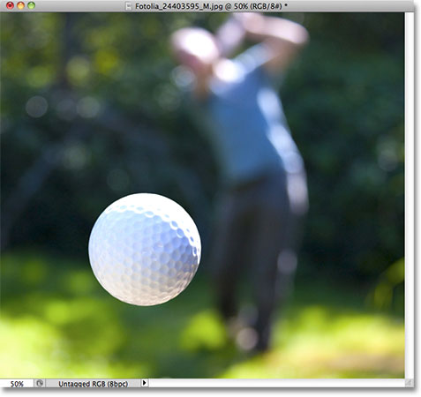

Step 1: Select The Ellipse Tool

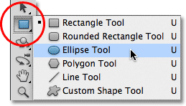

Step 2: Select The “Paths” Option
With the Ellipse Tool selected, the Options Bar along the top of the screen changes to show us various options for working with the tool. Near the far left of the Options Bar is a series of three icons, each one representing a different type of shape we can draw in Photoshop. We can draw vector-based shapes, paths, or pixel-based shapes. Click on the middle of the three icons to choose the Paths option:

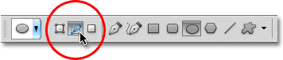

Step 3: Draw Your Path
With the Ellipse Tool selected and Paths chosen in the Options Bar, click inside your document and drag out an elliptical path. Holding your Shift key down as you drag will force the path into a perfect circle. To draw the path out from its center rather than from a corner, hold down your Alt key as you drag. If you need to reposition the path as you’re drawing it, hold down your spacebar, drag the path to a new location, then release your spacebar and continue dragging.
In my case, I’m going to draw a circular path around the golf ball. The path appears as a thin outline:

Step 4: Select The Type Tool
With our path drawn, we can add our text. Select the Type Tool from the Tools panel:

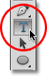

Step 5: Choose Your Font
With the Type Tool selected, choose your font settings from the Options Bar. I’m going to use Futura Condensed Medium set to 13 pt. My text color is set to white:

Step 6: Move The Cursor Over The Path
Move the Type Tool directly over the path. The cursor icon will change to an I-beam with a dotted wavy line through it. This tells us we’re about to add text directly to the path itself:

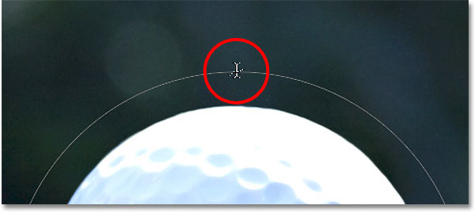

Step 7: Click On The Path And Add Your Type
Click anywhere along the path and begin adding your text. The spot you click on is where the text will begin, but don’t worry if you’ve clicked on the wrong spot because we can easily move the text around on the path once we’ve added it, as we’ll see in a moment. As you type, the text follows the direction of the path:
Continue adding your text along the path. When you’re done, click on the checkmark in the Options Bar to accept it and exit out of Photoshop’s text editing mode:

Step 8: Select The Path Selection Tool
To reposition your text along the path, choose the Path Selection Tool from the Tools panel:
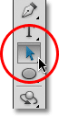
Select the Path Selection Tool.
Move the Path Selection Tool’s cursor anywhere over top of your text. You’ll see the cursor change from a black arrow into an I-beam with a small arrow on the side of it pointing left or right. Simply click on your text and drag it back and forth along the path with your mouse. Here, I’m dragging my text clockwise around the circle:

Flipping The Text Over The Path
Be careful as you’re dragging your text along the path that you don’t accidentally drag across the path. If you do, the text will flip to the other side and reverse direction:

